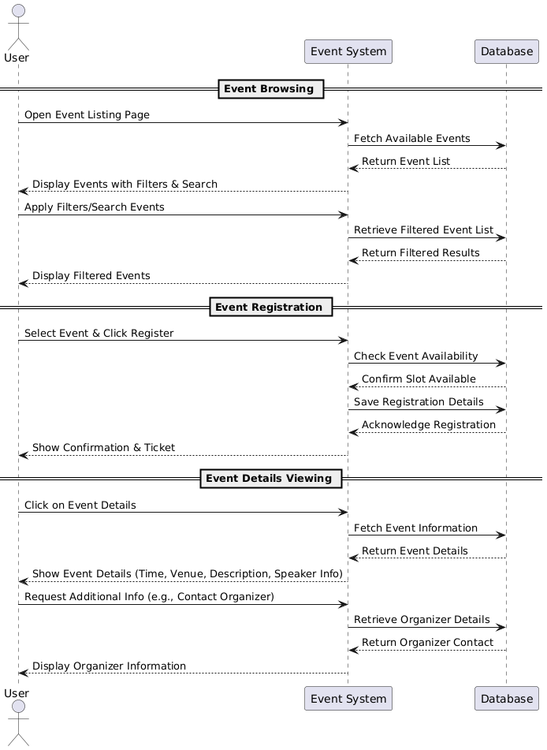
Database:
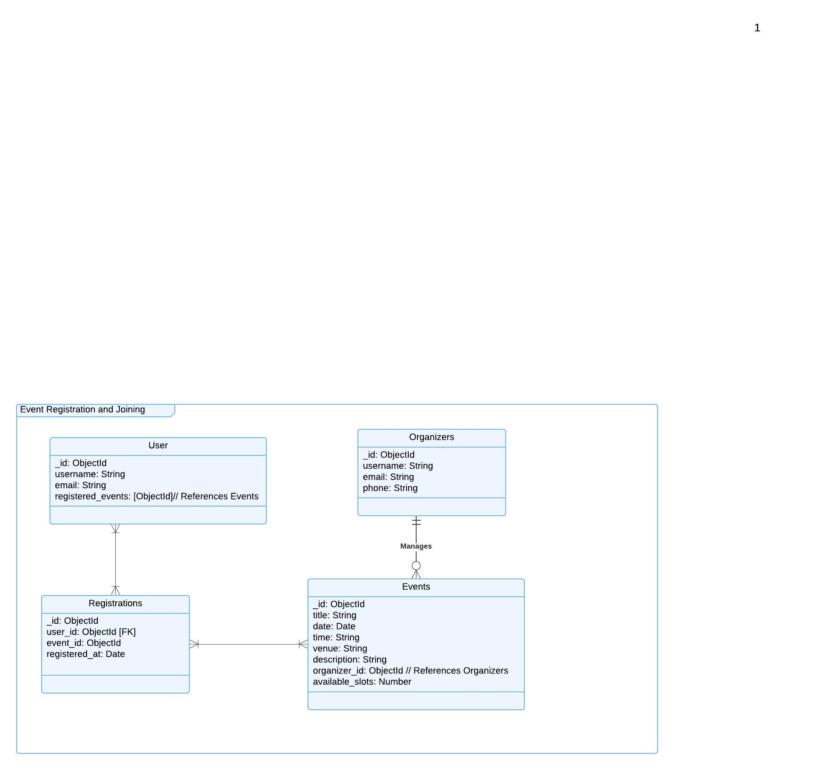

Functional Requirements (FRs)
Event Browsing
- FR1: The system shall allow users to browse a list of available events.
- FR2: The system shall provide filtering options (e.g., by date, location, category).
- FR3: The system shall allow users to search for events by title or keyword.
Event Registration
- FR4: The system shall allow users to register for an event.
- FR5: The system shall check event availability before confirming registration.
- FR6: The system shall store the user’s registration details in the database.
- FR7: The system shall display a confirmation message after successful registration.
- FR8: The system shall allow users to cancel their event registration.
Event Details Viewing
- FR9: The system shall allow users to view event details (title, time, venue, description).

Non-Functional Requirements (NFRs)
Performance Requirements
- NFR1: The system should handle at least 500 concurrent users without performance degradation.
- NFR2: Event search results should be displayed within 2 seconds.
Security Requirements
- NFR3: User data (e.g., registration details) shall be stored securely using encryption.
- NFR4: Only authenticated users should be able to register for events.
- NFR5: The system should prevent duplicate registrations for the same event.

